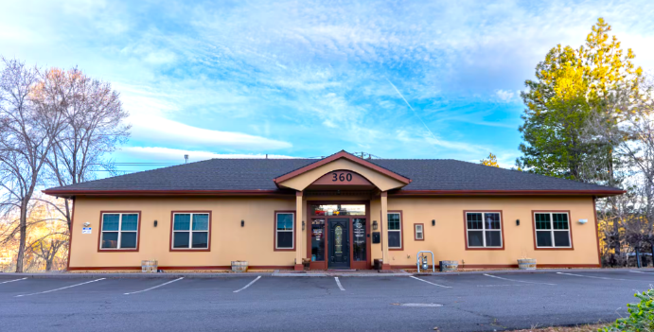
BEND OFFICE
IMOS
360 NW VERMONT PL.
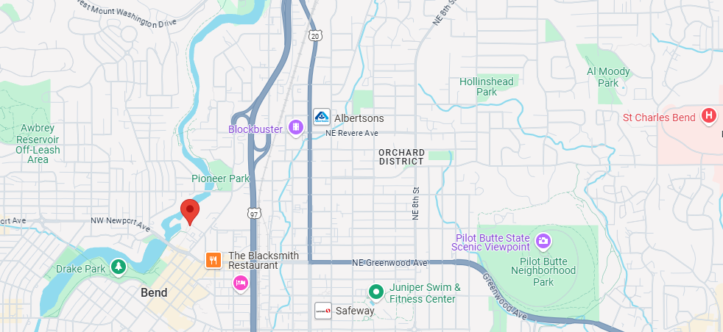
BEND, OR 97701

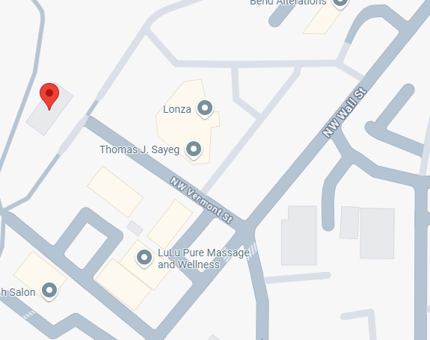

TRAVELING NORTH INTO BEND
- Travel North on Hwy 97/3rd St.
- Take exit 137 for Revere Ave toward Downtown
- Turn Left onto NW Revere Ave
- Turn Left on NW Wall
- Turn Right onto NE Vermont St.
- Vermont St. dead-ends into parking lot
TRAVELING SOUTH INTO BEND
- Travel South on Hwy 97
- Take Exit 137 Revere Ave toward Downtown
- Continue straight on NE Wall St.
- Turn Right onto NW Vermont St.
- Vermont St. dead-ends into parking lot
TRAVELING WESTBOUND INTO BEND
- Take HWY 20 West
- Continue onto Greenwood Ave
  - Turn right onto NW Bond St
  - Turn left onto NW Vermont St
- Vermont St. dead-ends into parking lot
TRAVELING EASTBOUND INTO BEND
- Take HWY 20 Eastbound
- Turn Left onto NE Empire Ave.
- Turn Right to merge onto Hwy 97 S
- Take Exit 137 Revere Ave toward Downtown
- Go Straight on NE Wall St.
- Turn Right onto NW Vermont St.
- Vermont St. dead-ends into parking lot

