MEDFORD EXAM LOCATION
IMOS
WHITTLE PLAZA
2587 WHITTLE AVE.
MEDFORD, OR 97504

Via I-5 South
Travel on I-5 Southbound
Take exit 30 for OR-62 W toward Klamath Falls | 0.3 mi
Turn left onto OR-62 W (signs for Crater Lk/Klamath Fls) | 0.8 mi
Keep right to continue on Crater Lake Hwy | 0.2 mi
Turn right onto Whittle Ave | 0.2 mi
Turn right into driveway

Traveling West (OR-140W):
Merge onto OR-140 W
Turn left onto OR-62 W/Crater Lake Hwy | 4.5 mi
Turn left onto Whittle Ave | 0.3 mi
Turn right into driveway

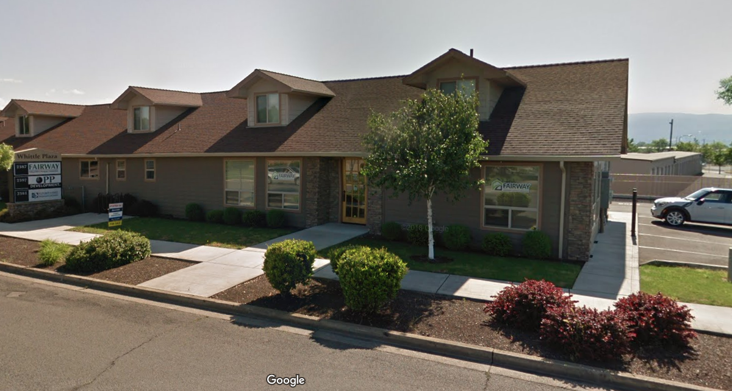

Via I-5 North:
Travel on I-5 Northbound
Take exit 30 for OR-62 E toward OR-238 W/N Medford/Crater Lk | 0.4 mi
Turn right onto OR-62 E | 0.7 mi
Keep right to continue on Crater Lake Hwy | 0.2 mi
Turn right onto Whittle Ave | 0.2 mi
Turn right into driveway
