**PORTLAND/TIGARD OFFICE**

6650 SW REDWOOD LN. #190

PORTLAND/TIGARD, OR 97224

**[enter through front; walk straight towards lobby/elevators; turn LEFT down hallway]**

**I-5 North:**

|  |
| --- |
| Merge onto I-5 N |
| Take exit 291 for Carman Dr. |
| Turn left onto Carman Dr./Upper Boones Ferry Rd. |
| Turn right onto SW Sequoia Pkwy. |
| Turn right onto SW Redwood Ln. |
| Destination is the building at the end of  the cul-de-sac |

**I-5 South:**

|  |
| --- |
| Merge onto I-5 S |
| Take exit 291 toward Carman Dr. |
| Turn right at the exit onto SW Upper Boones Ferry Rd. |
| Turn right onto SW Sequoia Pkwy. |
| Turn right onto SW Redwood Ln. |
| Destination is the building at the end of  the cul-de-sac |

**PDX- Eastside (I-205):**

|  |
| --- |
| Merge onto I-205 S |
| Take the exit onto I-5 N |
| FOLLOW I-5 NORTH DIRECTIONS ABOVE |

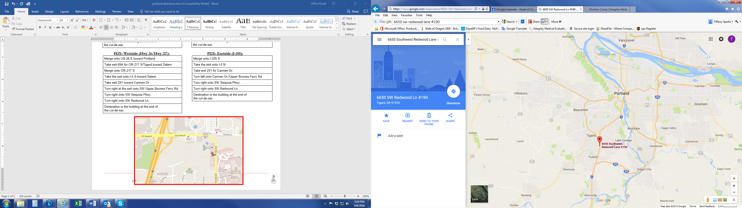

**PDX- Westside (Hwy 26/Hwy 217):**

|  |
| --- |
| Merge onto US-26 E toward Portland |
| Take exit 69A for OR-217 S/Tigard toward Salem |
| Merge onto OR-217 S |
| Take the exit onto I-5 S toward Salem |
| FOLLOW I-5 SOUTH DIRECTIONS ABOVE |

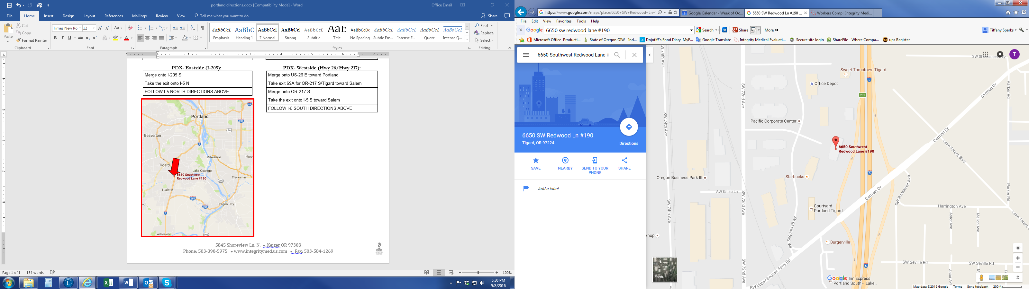[](https://www.google.com/url?sa=i&rct=j&q=&esrc=s&source=images&cd=&cad=rja&uact=8&ved=0ahUKEwiVg8G9t73QAhUW-GMKHSe4DpQQjRwIBw&url=https://www.practicelink.com/Info/GoWebPage.aspx?urlId%3D59785074%26sourceId%3D545&psig=AFQjCNH7kwHRZZJYow47AEtdj40YAtFPiA&ust=1479940809401993)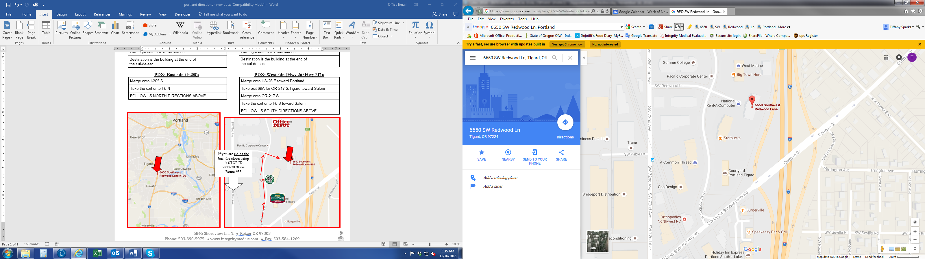[Image result for office depot logo](http://www.google.com/url?sa=i&rct=j&q=&esrc=s&source=images&cd=&cad=rja&uact=8&ved=0ahUKEwi8_KHBhYHPAhVRx2MKHWQQAtMQjRwIBw&url=http://www.freelogovectors.net/office-depot-logo-eps-file/&psig=AFQjCNElu_exeBAZ8Yl0USPQM3d6vfu4ng&ust=1473467813600978)[](https://www.google.com/url?sa=i&rct=j&q=&esrc=s&source=images&cd=&cad=rja&uact=8&ved=0ahUKEwjIoI35hIHPAhVQ82MKHdQjC50QjRwIBw&url=https://justindanielwood.wordpress.com/short-works/short-works/the-secret-history-of-starbucks-coffee/&psig=AFQjCNFAGHgGntNxHN3MF1tPyCdTDiUNCA&ust=1473467664546621)[](http://www.google.com/url?sa=i&rct=j&q=&esrc=s&source=images&cd=&cad=rja&uact=8&ved=0ahUKEwje0JmrhYHPAhUD4WMKHRPQAZ4QjRwIBw&url=http://www.keyword-suggestions.com/Y291cnR5YXJkIG1hcnJpb3R0IGxvZ28gMjAxNQ/&bvm=bv.131783435,d.cGc&psig=AFQjCNFt86hzHopxjoBMlLjE3iLktY_hYw&ust=1473467727718083)

If you are riding the bus, the closest stop is

SW 72nd/Kable via Route #38