5845 SHOREVIEW LN. N
KEIZER, OR 97303

Traveling via I-5:
If you are traveling on I-5 North: Take exit 260 toward Keizer and turn L at the exit onto Chemawa Rd.  OR  If you are traveling on I-5 South: Take exit 260B toward Keizer and turn R at the exit onto Chemawa Rd. | 1.5 mi
Turn Right on River Rd. | .1 mi
Take an immediate Left onto Promenade Way | 390 ft
At traffic circle, exit 1st right onto Inland Shores Way | 217 ft
Turn left onto Shoreview Ln. We are on the left.

Traveling West (US-20/ OR-22):
Travel on US-20 W
Slight right onto OR-22 W | 80.1 mi
Merge onto 1-5 N | 5.9 mi
CONTINUE FOLLOWING DIRECTIONS ABOVE
Traveling East (OR-18E/OR-22):
Travel on OR-18 E towards Salem/PDX
Merge onto OR-22 via ramp to Salem | 15.4 mi
Take the ramp to Salem | .7 mi
Continue on OR-22 | 9.7 mi
Take the OR-99E ramp on left to Keizer/PDX | 0.1 mi
Turn right onto OR-99 | 0.2 mi
Turn left on Commercial St., becomes Liberty St. | 1.6 mi
Continue onto River Rd. N | 0.2 mi
Turn left at signal light onto River Rd. N | 2.2 mi
Go through signal light at Lockhaven Dr. | 0.1 mi
Take an immediate Left onto Promenade Way | 390 ft
At traffic circle, exit 1st right onto Inland Shores Way | 217 ft
Turn left onto Shoreview Ln. We are on the left.
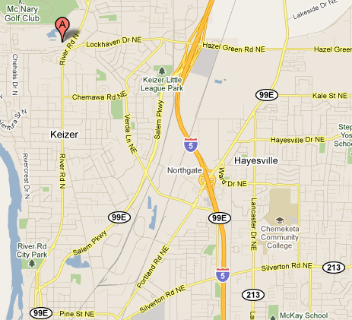

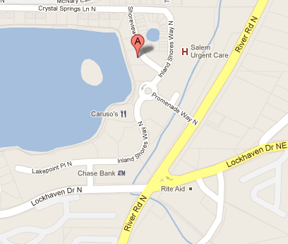


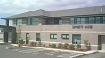

URGENT CARE

